Splunk Brute Force Detection Lab
Project Overview · sec-01
Project ID | Category | Status | Last verified
sec-01 | Cybersecurity Engineering | Completed (as a lab exercise) | 2026-10-26
Source | Location
GitHub repository | khancam15/splunk-bruteforce-detection-lab
Portfolio case study | khaneilcampbell.com/soc-automation-lab.html
Local folder | Local clone on your Mac (out of date, see section 4)
Related Claude conversation | None accessible
How to read the labels. [Verified] means I read it in the repository, its commit history or its screenshots. [Inferred] means it is my reasoning from that evidence and could be wrong. [Recommended] means a suggestion, not something that exists.
Contents. Project Reorientation · 1 Executive Summary · 2 Problem Statement · 3 Objectives · 4 Current Status · 5 Technology Stack · 6 System Architecture · 7 Workflow · 8 Key Engineering Decisions · 9 Challenges and Solutions · 10 Current Limitations · 11 Next Steps · 12 Career Relevance · 13 Last Updated

Project Reorientation
A five-minute read to pick the project back up.
Where you left off. [Verified] The lab itself was built and run on 2026-03-29. The last work was documentation: on 2026-10-24 and 25 a docs/portfolio-review branch restructured the README and renamed links. That branch is not merged into main.
What the system does. [Verified] A Kali Linux VM sends repeated wrong-password SMB logons to a Windows 11 VM. Windows logs each failure as Event ID 4625, a Splunk Universal Forwarder ships the log to Splunk Enterprise, and an SPL search flags 10 or more failures from one source against one account in a five-minute window. A Python script then pulls those alerts through the Splunk REST API and writes a Markdown case note.
How the architecture works. Two VMs, an attacker and a target with the forwarder, plus Splunk Enterprise. [Inferred] Splunk most likely ran on the Mac itself, because both the Splunk web screenshot and the script use localhost. The only automation is soc_automation.py, which talks to Splunk’s management port (8089). The diagram is in section 6.
What you learned. Windows authentication logging, log forwarding, SPL aggregation and thresholds, REST API authentication with session keys, and safe handling of lab credentials.
What remains unresolved.
- [Verified] The case-note screenshot labels a 16-failure alert High, but the committed script labels anything under 20 as Medium. The screenshot came from a script version that is not in git.
- [Verified] The search counts each failure twice, once for the account name - and once for administrator (see the Engineering Learning Guide, section 7).
- [Verified] The docs/portfolio-review branch is unmerged, and your local folder is missing soc_automation.py.
What to work on next. Merge the docs branch, then fix the double count in the SPL. Section 11 has the full list.
Explain it without AI in one breath. “I simulated an SMB password-guessing attack in an isolated lab, forwarded the Windows failed-logon events to Splunk, wrote a threshold detection for 10 failures in five minutes, and automated the triage note by querying Splunk’s REST API from Python.”

1. Executive Summary
This is a home security lab that shows the full path from attack to analyst paperwork. [Verified] It simulates a brute-force attack, detects it in Splunk, and turns the detection into a written case note automatically. It is published as a portfolio piece on GitHub and on khaneilcampbell.com, and the README describes it as “complete as a lab exercise”.

2. Problem Statement
[Verified] The README frames it as an end-to-end SOC workflow: threat simulation, detection engineering, and alert triage documentation. [Inferred] The practical problem is that analysts repeat the same lookup and note-writing for every brute-force alert; the lab shows how that step can be scripted, and gives you hands-on evidence of blue-team skills for job applications.

3. Project Objectives
[Verified] From the README “Lab Objectives”:
- Simulate SMB brute-force attempts from Kali to Windows 11.
- Forward Windows Security logs (EventCode 4625) to Splunk.
- Build SPL detections for brute-force behavior.
- Pull detection results programmatically from the Splunk REST API.
- Generate structured SOC case notes automatically.

4. Current Development Status
Area | State | Evidence
Lab environment and attack | Completed | WALKTHROUGH.md phases 1 and 2; screenshots 01 to 03
Splunk ingestion and detections | Completed | Screenshots 04 to 06: 81 events, 8 threshold rows
Python case-note automation | Completed | soc_automation.py; screenshots 07 and 08
Documentation refresh | In progress | docs/portfolio-review branch, 2 commits, not merged
Severity mismatch in screenshot | Open | Script grades 16 failures Medium; screenshot shows High
Double counting by Account_Name | Open | Screenshot 05 shows paired rows for - and administrator
Local copy | Out of date | Local HEAD e7f4385 (2026-04-26), 5 commits behind main, no soc_automation.py
Blocked: nothing. Planned: nothing is planned in the repository itself.

5. Technology Stack
Technology | Role in this project
VirtualBox 7.2.6 | Runs the two VMs on a host-only network so attack traffic never leaves the laptop
Kali Linux | Attacker; runs smbclient in a loop with a wrong password
Windows 11 | Target; records each failed logon as Event ID 4625
Splunk Universal Forwarder | Reads the Windows Security log ([WinEventLog://Security]) and sends it to the indexer
Splunk Enterprise | Stores events in index=main and runs the SPL detections
SPL | Search language used to aggregate, threshold and grade failed logons
Python 3 with requests | Calls the Splunk REST API and writes the case note
Markdown | Format of the generated case note
Git and GitHub | Version control, publishing, and the portfolio’s evidence trail

6. System Architecture
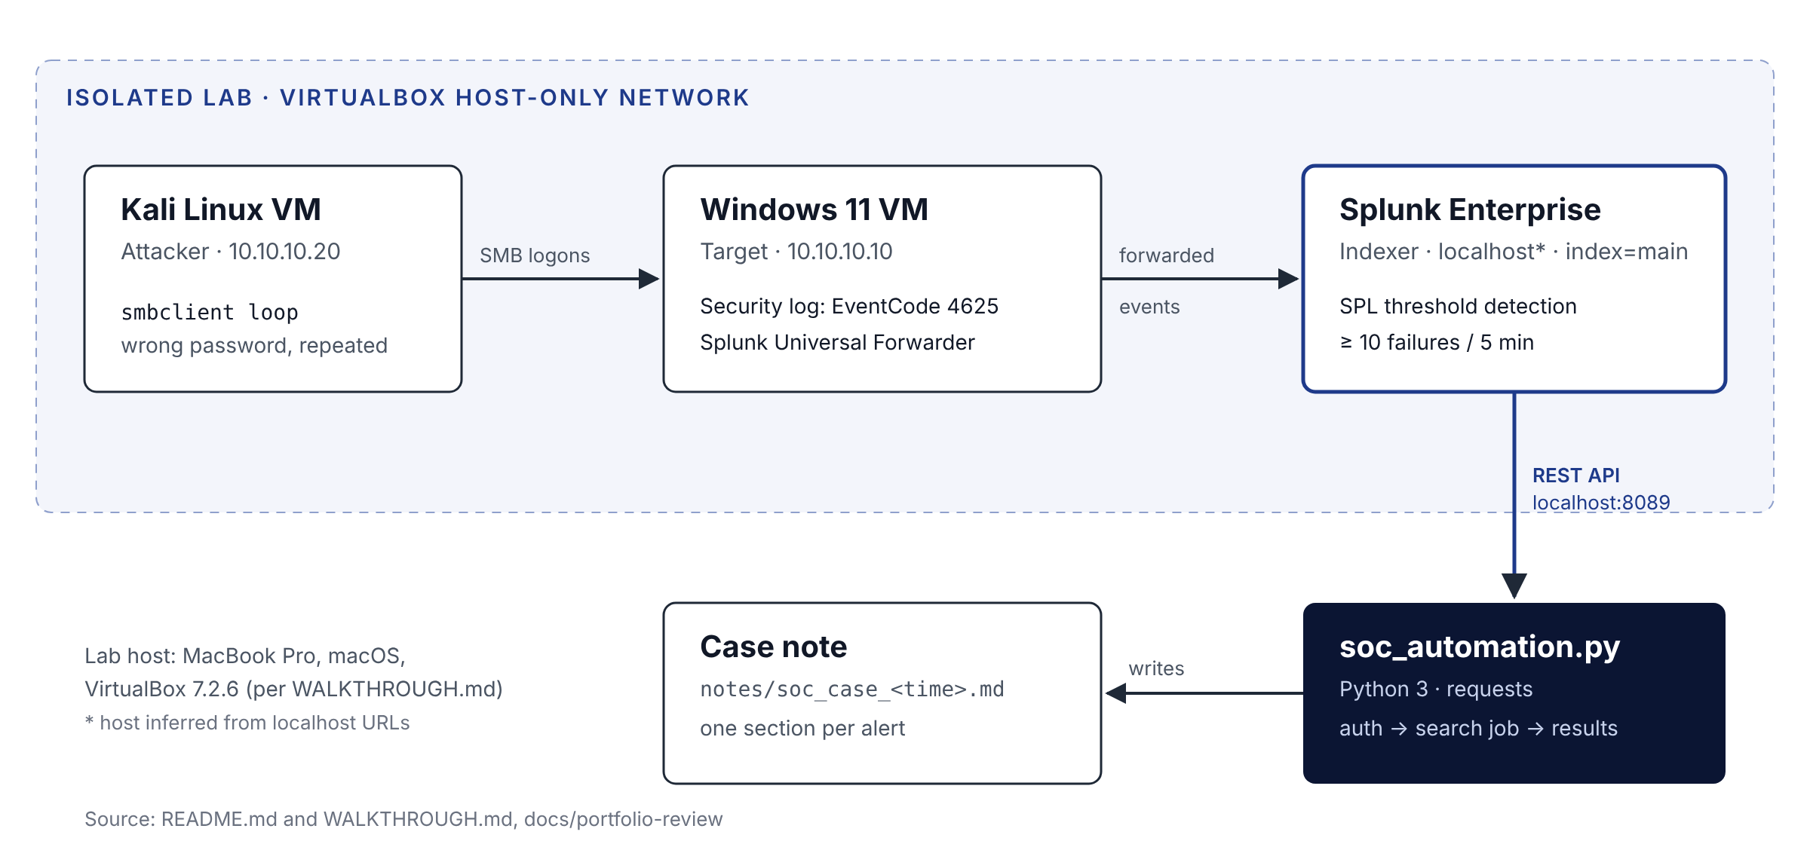
Lab architecture, drawn from README.md and WALKTHROUGH.md
[Verified] Data path: failed SMB logons on the Windows VM are written to the Security log as EventCode 4625, forwarded to Splunk, aggregated by account and source address in five-minute buckets, and pulled by the script, which writes one case note per run.

7. Workflow Explanation
- Prepare the lab. Give the Windows VM a static IP (10.10.10.10) on the host-only network and confirm Kali can reach it with ping.
- Forward logs. Install the Universal Forwarder on Windows and monitor the Security event log into index=main.
- Attack. From Kali, loop smbclient -L //10.10.10.10 -U administrator%wrongpass. [Verified] The walkthrough records the account locking out (NT_STATUS_ACCOUNT_LOCKED_OUT).
- Confirm ingestion. Search EventCode 4625 in Splunk. [Verified] 81 events from 10.10.10.20.
- Detect. Run the threshold search: 10 or more failures per source, account and five-minute bucket. [Verified] 8 rows, all High.
- Automate triage. Run soc_automation.py with SPLUNK_USER and SPLUNK_PASS set. It authenticates, runs the search as a blocking job, fetches results, and writes notes/soc_case_<timestamp>.md.
- Review. Read the case note and follow its recommended actions: look for a 4624 success after the failures, decide whether the source is expected, and block or lock if not.

8. Key Engineering Decisions
Decision | Why (as documented) | Label
Host-only network for all attack traffic | Keeps simulation inside the lab (SECURITY.md, WALKTHROUGH phase 0) | Verified
Threshold of 10 failures in 5 minutes | Simple, explainable brute-force signal; README notes it was tuned on one run | Verified
Exclude 127.0.0.1 and ::1 | Removes local noise from the detection | Verified
Credentials only from environment variables | Restored script dropped a hard-coded default password (commit 5c6dd51) | Verified
exec_mode=blocking search job | One request waits for the search to finish, so no polling loop is needed | Inferred
Markdown case note instead of a ticket | Keeps the lab self-contained; README lists no ticketing integration | Verified
Two copies of the SPL (saved search and script constant) | The script version adds logon types, reasons, host and a severity grade | Verified

9. Challenges and Solutions
Challenge | Solution | Evidence
Screenshot file names with trailing spaces and a typo broke links | Renamed files and fixed paths | Commits 2026-03-29 to 2026-04-01
Secrets risk in a public repo | Expanded .gitignore, added SECURITY.md, removed default password from script | Commits 2026-04-26 and 5c6dd51
Script removed from the repo on 2026-04-01 | Restored on 2026-10-11 with env-only credentials | Commits 817482a and 5c6dd51
Repo name and links drifted after a rename | Docs branch updates titles and links | Commit ba1347a (unmerged)
[Inferred] Git history shows a lot of clean-up churn; the walkthrough’s “Git troubleshooting” note (diverged branches, file names, .gitignore) matches it.

10. Current Limitations
[Verified] From the README:
- Single host, single tenant: assumes index=main and this lab’s sourcetype.
- SPLUNK_HOST is hard-coded and TLS certificate verification is off.
- The threshold was tuned against one simulated attack, not baseline traffic.
- The case note is a local Markdown file; nothing goes to a ticketing system.
[Verified] Also from the code: the script exits with status 0 even when a request fails, and it counts the same failure under two account names.

11. Next Development Steps
- [Recommended] Merge docs/portfolio-review into main after reviewing it.
- [Recommended] Pull the latest main into your local folder, and decide whether to remove the older duplicate clone.
- [Recommended] Fix the double count, for example by using the target account only (mvindex(Account_Name, 1)), then re-run and update the screenshots.
- [Recommended] Reconcile the severity rule with the published case-note screenshot.
- [Recommended] Return a non-zero exit code on failure so the script can run from a scheduler.
- [Recommended] Add a 4624-after-4625 correlation search (success after failures), which the case note already tells analysts to check.

12. Career Relevance
Role focus | What this project shows
Cybersecurity and SOC | Event ID 4625 analysis, SPL detection with thresholds, MITRE ATT&CK T1110 mapping, triage notes
AI Solutions Engineering | Honest, documented use of Claude as a working partner, with your own validation of every output
Enterprise automation | REST API integration, session-key auth, environment-based secrets, repeatable output

13. Last Updated
Field | Value
Last verified | 2026-10-26
Verified against | GitHub main at c11e44c (2026-10-12) and docs/portfolio-review at ba1347a (2026-10-25)
Also read | 8 screenshots, local folder git metadata
Prepared by | Claude, for review by Khaneil Campbell

